**SAMPLE TASK**

## Following are some sample tasks that will allow us to evaluate your talent.

## NOTE:

## The Candidate can choose to do any one of these tasks.

## The format for submitting the tasks is in Jupyter notebook/Python Script/Document unless otherwise mentioned. You can upload your files onto a cloud drive and submit the link for the same or send the link of the GitHub repository where you’ve uploaded the task.

## The tasks are self contained. No further questions will be entertained.

## Data Science

**DS1**: A company has a dataset that has long descriptions (Introduction) of it’s products, Now as a DS Help the company to make a text summariser that takes these descriptions as input and summarises them into shorter versions without loosing the context. The length of the summary is also adjustable by the user. Also Document each stage of the code by adding proper comments. Mention the key technologies used and why.

Dataset-

https://drive.google.com/file/d/1TzBe2kUd7kTpLfh5youSFQPFtFUv1xbU/view?usp=sharing

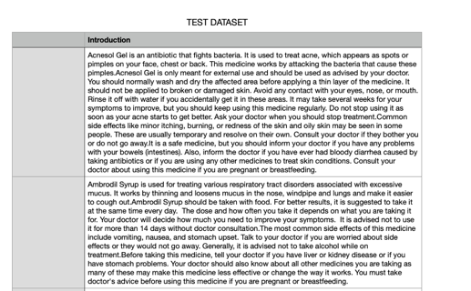

**DS2** : For a certain App ‘Khealth’ that can be downloaded from play store (android) , use your scraping skills to fetch all the images. Input different use cases (symptoms) and scrape the images that you see on the screen of different conditions (or diseases). Sample images from the app are given below as example.

Note - VPN will be required to download and use this app as it is available on USA’s play store